**Day 1**

1. **What you rate your current Power BI literacy level on a scale of 1-10** 
   1. 1
   2. 2
   3. 3
   4. 4
   5. 5
   6. 6
   7. 7
   8. 8
   9. 9
   10. 10

**Knowledge Check 1**

1. Power BI is a powerful business analytics solution, but it does not:
   1. Visualize your data
   2. **Independently build predictive models**
   3. Embed insights in your app or website
   4. Connect to hundreds of data sources and bring your data to life with live dashboards and reports
2. As a Power BI report developer, your typical workflow begins with creating reports in ________. Then, you publish them to the ________, where you can continue modifying them.
   1. **Power BI Desktop - > Power BI Web Service**
   2. Power BI Web Service - > Power BI Desktop
   3. Power BI Mobile app -> Power BI Desktop
   4. Power BI Mobile app -> Power BI Web Service
3. Which BI layer involves building relationships between multiple tables to build a suitable model?
   1. ETL layer
   2. **Modeling layer**
   3. Report layer
   4. Web service layer

**Knowledge Check 2**

1. Which pane in Power BI desktop allows you to customize data colors, text size, conditional formatting, etc.?
   1. Page pane
   2. Ribbon pane
   3. Fields pane
   4. **Visualizations pane**
2. Which of the following is NOT true about the slicer?
   1. Slicers make it easier to see the current filtered state
   2. Easily dive into valuable and insightful ‘corners’ of the dataset
   3. Slicers filter the portion of the dataset shown in the other visualizations in a report
   4. **Slicers are used to delete unwanted rows from the data tables**

**Day 2**

**Warm up**

1. Which example did you find the most relevant to how you plan to use Power BI?
   1. Customer Segmentation Dashboard
   2. Sales Scorecard Dashboard
   3. Sales Analysis Dashboard
   4. Product Sales Dashboard
   5. Email Engagement Analytics Dashboard
   6. Marketing Campaign Insights Dashboard
   7. Ad Display Campaign Dashboard
   8. Finance Dashboard
   9. Financial Analytics Dashboard
   10. Quarterly Financial Performance Dashboard
2. Which example did you like the best?
   1. Customer Segmentation Dashboard
   2. Sales Scorecard Dashboard
   3. Sales Analysis Dashboard
   4. Product Sales Dashboard
   5. Email Engagement Analytics Dashboard
   6. Marketing Campaign Insights Dashboard
   7. Ad Display Campaign Dashboard
   8. Finance Dashboard
   9. Financial Analytics Dashboard
   10. Quarterly Financial Performance Dashboard

**Knowledge Check 1**

1. What visualization is ideal to display a single value that measures the progress towards a goal?
   1. Bar chart
   2. Card visualization
   3. Donut chart
   4. **Radial gauge chart**
2. Which visualization could you use to display a comparison of categories to each other based on a single metric?
   1. Donut chart
   2. Line chart
   3. Card visualization
   4. **Bar chart**

**Knowledge Check 2**

1. Which filter would you use to create a destination report page that focuses on a specific entity?
   1. Page filter
   2. Visualization filter
   3. Report filter
   4. **Drill through filter**
2. Which of these statements is NOT true about slicers?
   1. Slicer is a visualization of a filter
   2. **By default, slicers on a page do not affect all the other visualizations on that page**
   3. Slicers make it easier to see the current filtered state
   4. Slicers create more focused reports

**Day 3**

**Knowledge Check 1**

1. Which of the following is NOT true about Power Query?
   1. It is a data connectivity and data preparation technology
   2. Power Query supports data sources including a wide range of file types
   3. It can be used to reshape data to fit needs with a no-code user experience
   4. **The data transformation capabilities are specific to a data source**
2. In Power BI, what can you click to see a list of the most common data sources you can connect to?
   1. Enter Data
   2. Database
   3. **Get Data**
   4. Edit Queries

**Knowledge Check 2**

1. Which of the following is NOT true about Power BI web service?
   1. Power BI web service was built for collaboration
   2. **Power BI web service is strictly a machine-based offline service**
   3. You can store and manage Power BI reports in the cloud in the Power BI web service.
   4. You can publish reports from the Power BI Desktop to the Power BI service
2. Finish this statement: One dashboard _______
   1. **is associated with a single workspace**
   2. can display visualizations from only one dataset
   3. can display visualizations from only one report
   4. can't display visualizations pinned from other tools (for example, Excel)

**Day 4**

**Knowledge Check 1**

1. [True or False] One should always try to present as much data as possible on a single chart / graph.
   1. True
   2. **False**
2. [Select all that apply] Which of these increments creates a proportionate and intuitive scale for a visualization?
   1. **0,100,200,300**
   2. 0, 5, 8, 18, 25
   3. **1,2,3**
   4. 0,100, 400, 2000, 8000

**Knowledge Check 2**

**\* first 6 questions refer to the picture on slide 240**

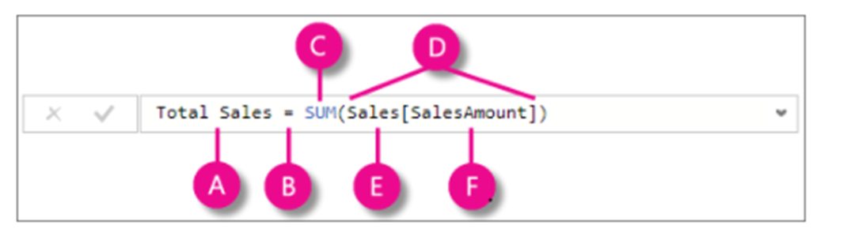

1. What letter on the image represents Parenthesis for Sum
   1. A
   2. B
   3. C
   4. **D**
   5. E
   6. F

1. What letter on the image represents Measure name
   1. **A**
   2. B
   3. C
   4. D
   5. E
   6. F
2. What letter on the image represents beginning of the formula
   1. A
   2. **B**
   3. C
   4. D
   5. E
   6. F
3. What letter on the image represents Referenced table
   1. A
   2. B
   3. C
   4. D
   5. **E**
   6. F
4. What letter on the image represents Referenced column
   1. A
   2. B
   3. C
   4. D
   5. E
   6. **F**
5. What letter on the image represents DAX function
   1. A
   2. B
   3. **C**
   4. D
   5. E
   6. F
6. [Select all that apply] Where can we apply DAX functions? (select all that apply) *
   1. **Measures**
   2. **Calculated columns**
   3. **Calculated tables**
7. Which one is NOT true about DAX functions? *
   1. CALCULATE > Evaluates an expression in a context that is modified by the specified filters
   2. **SUM > operates over multiple columns**
   3. AVERAGE > Returns the average (arithmetic mean) of all the numbers in a column
   4. SUMX > Returns the sum of an expression evaluated for each row in a table